**AUTOMATIC MEASUREMENT OF MRTD PARAMETER USING THERMAL IMAGER**

**INTRODUCTION :**

**Thermal Imager:**

A thermo graphic camera (also called an infrared camera or thermal imaging camera, thermal camera or thermal imager) is a device that creates an image using infrared (IR) radiation, similar to a normal camera that forms an image using visible light. Instead of the 400–700 nanometer (nm) range of the visible light camera, infrared cameras are sensitive to wavelengths from about 1,000 nm (1 micro metre or μm) to about 14,000 nm (14 μm). The practice of capturing and analyzing the data they provide is called thermography.

**Types :** cooled and uncooled thermal imager.

**MRTD :**

Minimum resolvable temperature difference (MRTD) is a measure for assessing the performance of infrared cameras, and is inversely proportional to the modulation transfer function.

Typically, an operator is asked to assess the minimum temperature difference at which a 4-bar target can be resolved. This minimum difference will change with the spatial frequency of the bar target used. A curve of MRTD against spatial frequency is obtained which characterises the performance of the imaging system.

Modern infrared imaging systems can have low spatial frequency MRTDs of tens of millikelvins.

**MRTD Parameter:**

MRTD is complex parameter that combines thermal imager response, image transformation and sensitivity limit, providing possibility for imager range prediction. Because of that it is one of the most important thermal imager parameters.

**MRTD measurement:**

The MRTD is the minimum temperature difference which allows an observer to resolve a test pattern in accordance with a given criterion. MRTD is a function of spatial frequency of the test pattern. It depends on measurement temperature and may depend on the orientation of the test pattern.

**Automatic Measurement Techniques:**

1. **MAN vs MACHINE:**

**Introduction:**

Modulation Transfer Function (MTF) is a critical parameter in assessing the imaging performance of optical systems, especially in the context of Modulation Transfer Function measurement of the MRTD (Minimum Resolvable Temperature Difference). The MRTD is a key metric in evaluating the thermal imaging systems' capability to resolve temperature differences. Traditionally, two methods are employed for MRTD measurement: manual and machine-based techniques. This essay aims to compare and contrast these two methodologies, highlighting their respective advantages, limitations, and applications.

**Manual MRTD Measurement:**

Manual MRTD measurement involves human observers visually inspecting the image displayed on a thermal imaging system and identifying the temperature differences between adjacent targets. This technique relies heavily on the observer's visual acuity, judgment, and training. The observer typically uses a test chart consisting of alternating cold and hot targets with varying spatial frequencies.

**Experiment:**

When the average of the lowest two temperature contrasts is taken as the minimum observable contrast, by definition this has to be at least as large as the minimum value itself. In Table I we observe that the MRTD values calculated in the former way have generally a slightly higher value, whereas the uncertainty not necessarily increases. This approach could be classified as slightly more robust, albeit yielding a more conservative MRTD curve.

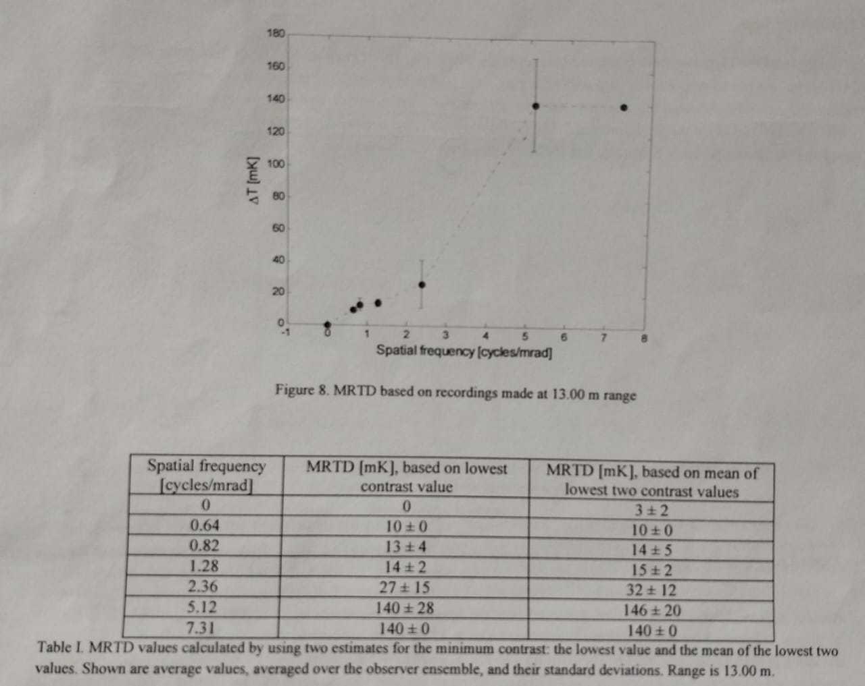

Analysis of observer responses to a set of images recorded at range 8.35 m yields the results plotted in Fig. 9. Regarding the results for this set of images the same comments can be made as for the previous set. For this case the spatial frequencies for all patterns are smaller than the cut-off frequency and therefore all patterns should be identifiable provided that the contrast is high enough. We observe that the curve in Fig. 9 flattens out for the highest spatial frequency, where one would expect a stronger increase, Currently we do not have an explanation for this possibly unexpected behavior.

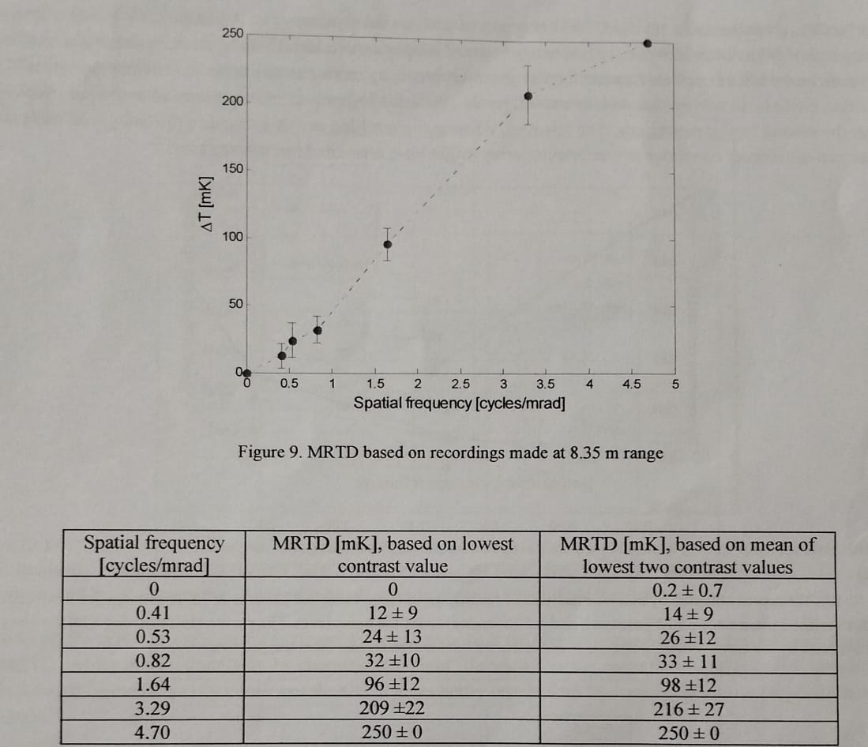

**Advantages:**

1. Flexibility: Manual measurement allows for flexibility in adapting to different testing environments and conditions.

2. Cost-effective: Requires minimal equipment beyond the thermal imaging system and test chart.

3. Real-world relevance: Mimics the human visual perception process, making it relevant for assessing system performance in practical scenarios.

**Limitations:**

1. Subjectivity: Results can vary based on the observer's experience, fatigue, and individual perception biases.

2. Time-consuming: Manual measurement is labor-intensive and time-consuming, especially for large datasets.

3. Inconsistency: Inter-observer variability can lead to inconsistent results, affecting the repeatability and reliability of measurements.

**Machine MRTD Measurement:**

Machine MRTD measurement automates the process using specialized software algorithms to analyze the thermal images and quantify the MRTD values objectively. This approach eliminates human subjectivity and can provide more consistent and repeatable results.

**Experiment:**

The MRTD curves obtained from the recordings made at 8.35 m range are presented in following images. Also for these recordings machine analysis of the smallest patterns proved to be difficult. This is unfortunate since it limits the spatial frequency range of the analysis. A comparison between the observer-test MRTD and the machine-analysis MRTD in following image, shows similar behavior for larger frequencies when the threshold is set higher, but with quite a difference in the absolute values for the required temperature contrast. For the smaller spatial frequencies the human observer seems more sensitive than the machine, at least for the simple analysis we have implemented here.

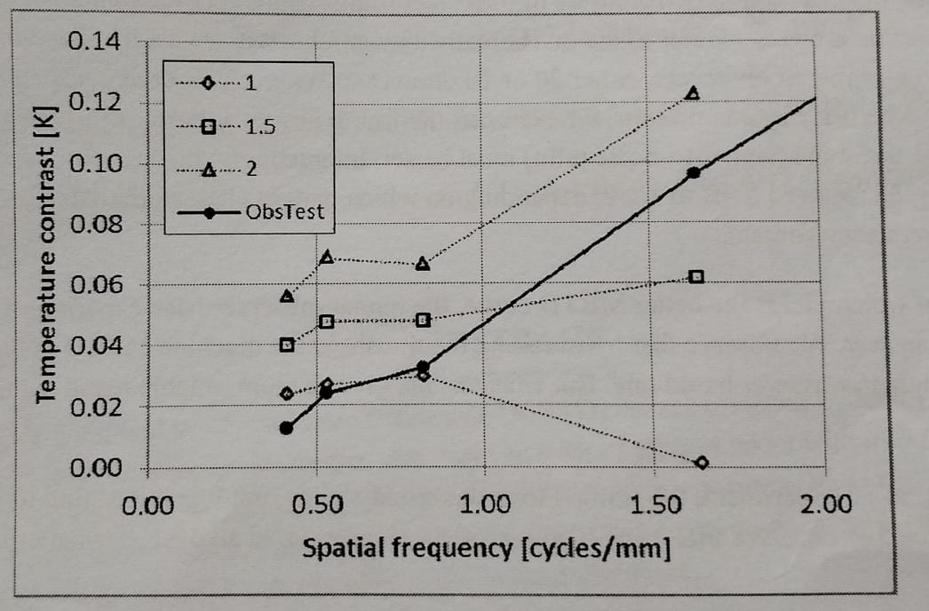

Considering the analysis based on the pertinent Fourier component we observe quite a good match between the observer- test MRTD and the machine analysis, by choosing the "right" threshold, 2x the noise floor. In this case it seems that the analysis based on the frequency content of the signal gives better results than the analysis based on the modulation amplitude.

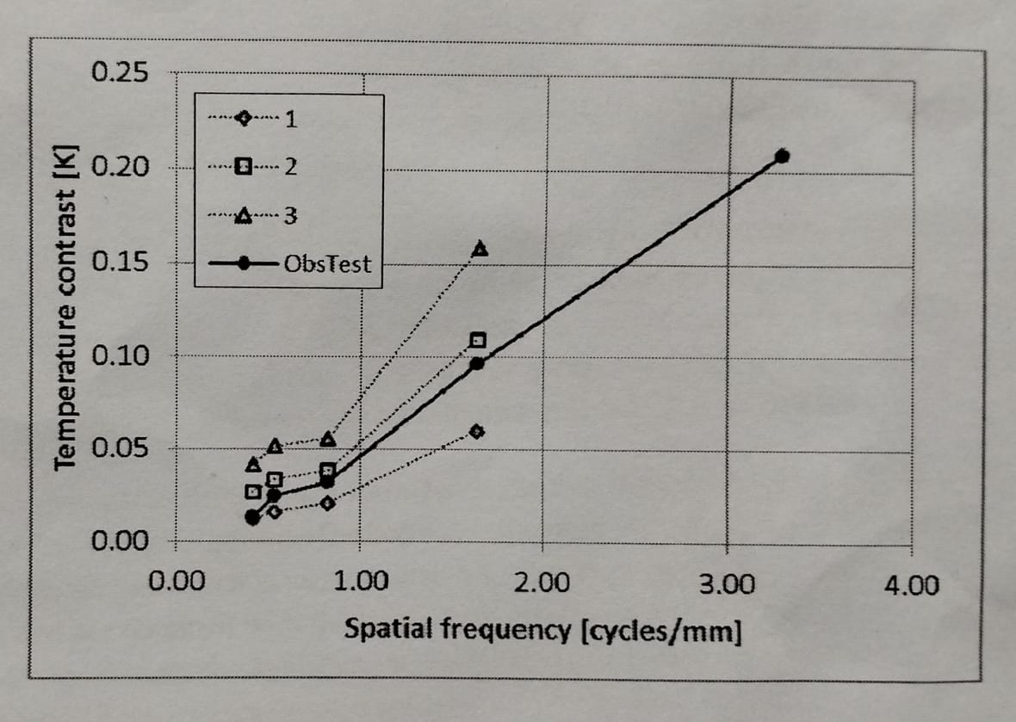

**Advantages:**

1. Objectivity: Machine measurement eliminates human bias, ensuring more consistent and reliable results.

2. Efficiency: Automating the process reduces the time and resources required for MRTD assessment, especially for large datasets.

3. Precision: Machine algorithms can detect temperature differences with higher precision than human observers, leading to more accurate measurements.

**Limitations:**

1. Initial investment: Requires investment in specialized equipment and software, which can be costly.

2. Calibration: Machine-based systems require regular calibration to maintain accuracy, adding to the operational overhead.

3. Limited applicability: Some complex scenarios may still require human judgment, limiting the scope of machine-based measurements.

1. **SUBJECTIVE MRTD vs OBJECTIVE MRTD :**

**Introduction:**

Modulation Transfer Function (MTF) is a crucial metric for assessing the performance of thermal imaging systems, with Minimum Resolvable Temperature Difference (MRTD) being a key component. MRTD measurement techniques can be broadly categorized into subjective and objective methods. Subjective measurement relies on human observers' visual interpretation, while objective measurement utilizes automated algorithms for analysis. This essay aims to delve into the characteristics, advantages, limitations, and applications of both subjective and objective MRTD measurement techniques.

**Subjective MRTD Measurement:**

Subjective MRTD measurement involves human observers visually inspecting thermal images displayed by the imaging system and determining the minimum temperature difference between adjacent targets that can be resolved. Observers typically use MRTD test charts containing alternating cold and hot targets with varying spatial frequencies.

**Advantages:**

1. Real-world relevance: Mimics human visual perception, making it relevant for assessing system performance in practical scenarios.

2. Flexibility: Allows for adaptation to different testing environments and conditions.

3. Low initial investment: Requires minimal specialized equipment beyond the thermal imaging system and test chart.

**Limitations:**

1. Subjectivity: Results can vary based on observer experience, fatigue, and individual perception biases.

2. Time-consuming: Subjective measurement is labor-intensive and time-consuming, especially for large datasets.

3. Inter-observer variability: Different observers may interpret images differently, leading to inconsistent results.

**Objective MRTD Measurement:**

Objective MRTD measurement automates the process using specialized software algorithms to analyze thermal images and quantify MRTD values. These algorithms typically detect temperature differences between targets with high precision and repeatability.

**Specialized Software Algorithms :**

* NETD – Noise Equivalent Temperature Difference.
* MTF – Modulation Transfer Function.
* SiTF – Signal Transfer Function.

**Advantages:**

1. Objectivity: Eliminates human bias, ensuring consistent and reliable results.

2. Efficiency: Automates the process, reducing time and resources required for MRTD assessment, especially for large datasets.

3. Precision: Algorithms can detect temperature differences with higher precision than human observers, leading to more accurate measurements.

**Limitations:**

1. Initial investment: Requires investment in specialized equipment and software, which can be costly.

2. Calibration: Objective measurement systems require regular calibration to maintain accuracy, adding to operational overhead.

3. Limited applicability: Some complex scenarios may still require human judgment, limiting the scope of objective measurements.

1. **AUTOMATIC MEASUREMENT OF MRTD PARAMETER USING CNN :**

**Introduction:**

Modulation Transfer Function (MTF) is a critical metric in assessing the performance of thermal imaging systems, with Minimum Resolvable Temperature Difference (MRTD) being a key component. Automating the measurement of MRTD parameters using Convolutional Neural Networks (CNNs) presents an innovative approach to streamline and improve the accuracy of thermal imaging system evaluation. This essay explores the principles, advantages, challenges, and applications of automated MRTD measurement using CNNs.

**Principles of CNN-based MRTD Measurement:**

CNNs are a class of deep learning algorithms inspired by the biological visual cortex's structure and functioning. They excel at extracting features from images and learning hierarchical representations, making them well-suited for image analysis tasks. In the context of MRTD measurement, CNNs can be trained on labeled thermal images to detect temperature differences between targets and quantify MRTD values automatically.

**3 Layers of CNN :**

1.Convolutional Layer.

2.Pooling Layer.

3.Fully Connected Layer.

In this paper, the data set is enhanced by the following methods: 1) Cutting, the original image size collected in this paper is 80*80, and the four corners of the original image are respectively vertices, and 70*70 image size is cut, and each image can be Cut into 4 images. The cut image did not change the shape of the four-bar target, only changing the position of the four-bar target in the image. 2) Horizontal rotation, the rotated four-bar target image has no effect on classification. After an image is transformed by the above method, it will become 16 images of 70*70 size, and the entire data set will be expanded to 12800 images, of which 10000 images are used as training sets and 2800 images are used as test sets.

The CNN neural network used in this paper has six layers, defined as the FourLeNet model. The first layer is the convolution layer (C1). The number of convolution kernels is 5, the size is 3*3, and the sliding step size is 1. The left and right borders are filled with 1 layer, and the output image and the input image size are unchanged. After the first layer is convolved, the output size is 5*70*70; the second layer is the pooling layer (S2), and the maximum pooling strategy is adopted. The size is 2*2, the sliding step size is 2, and the output is 5*35*35 after pooling; the third layer is the convolution layer (C3), the number of convolution kernels is 12, and the convolution kernel size is 3*3. The input image is filled with 1 layer on the upper, lower, left and right borders, and the output image and the input image size are unchanged. After the output of the third layer convolution layer, the size is 12*35*35; the fourth layer is the pooling layer (S4). The same maximum pooling strategy is adopted, the kernel size is 2*2, the sliding step size is 2, and the output is 12*17*17 after the fourth layer is pooled; the fifth layer is the fully connected layer (F5), and the output size is 1000*1; the sixth layer is also a fully connected layer with an output size of 3*1, corresponding to the three label classifications of the four-bar target.

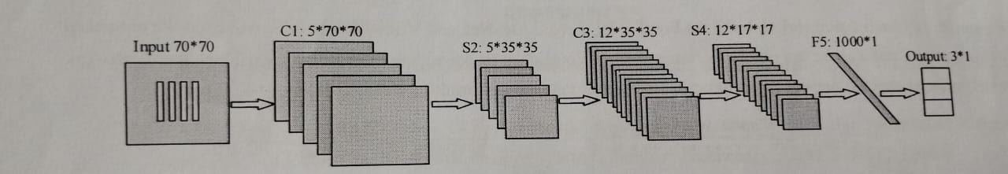

**Experiment:**

We used the Pytorch framework to build the FourLeNet, LeNet, AlexNet, and VGG-16 networks, and used the enhanced four-bar target dataset as the test object. We compared the FourLeNet model with the commonly used CNN neural network model on the enhanced four-bar target dataset. The correct rate, the test results are shown in Figure 5, Table 1.

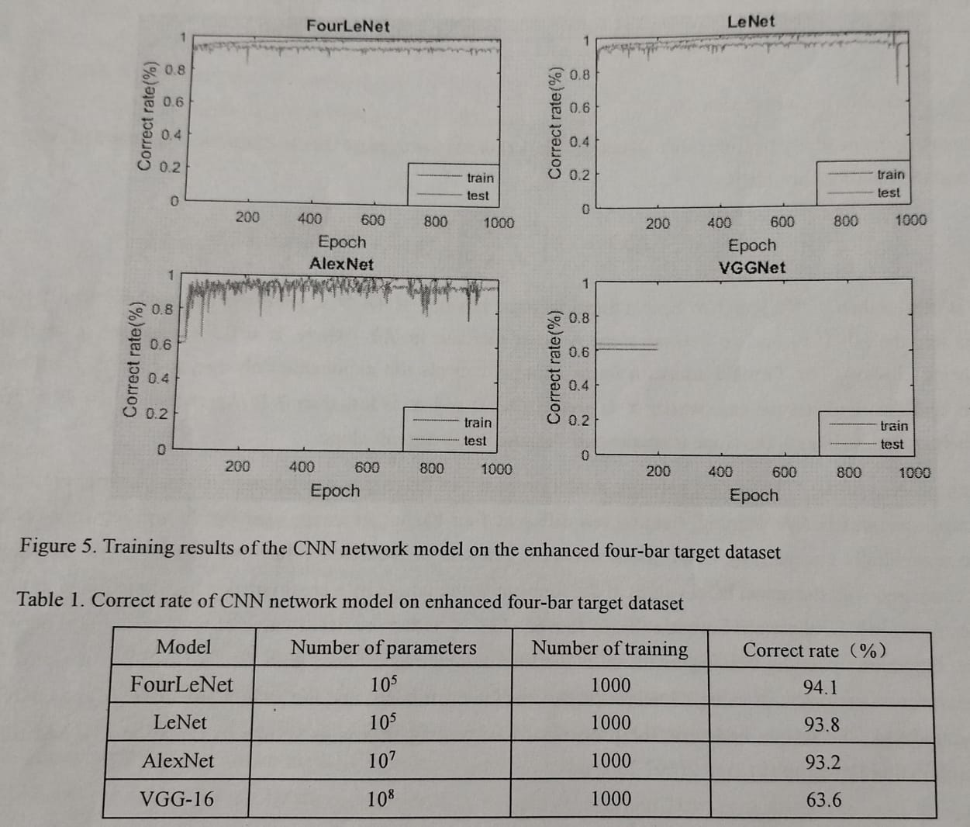

Through the above training results, it can be seen that the FourLeNet model combined with the ReLu activation function has obtained the best test results, which proves the superiority of the FourLeNet model. The VGG-16 model even has the problem of stagnation of growth rate. The accuracy of the FourLeNet network model on the enhanced four-bar target data set was 94%, reaching the limit of the correct rate. The factors affecting the accuracy rate limit are as follows: 1) The acquisition of the training data set and the test data set is subjectively judged by the human eye to determine the state of the four-shot target, and the selection of the threshold image is inevitably fluctuating, and the error of this part is difficult to eliminate. 2) The judgment state of the four-bar target image is greatly affected by the image noise, and the infrared image is usually uneven. 3) The influence of the uncertainty of the test system. Because the temperature difference in the test system is affected by both the black body temperature and the ambient temperature, the black body temperature and the ambient temperature will drift with time, making the temperature difference uncertain. If these effects can be eliminated, the correct rate of the FourLeNet network model can be further improved.

**Advantages:**

1. Objectivity: CNNs eliminate human bias, ensuring consistent and reliable MRTD measurements.

2. Efficiency: Automated measurement reduces the time and resources required for MRTD assessment, especially for large datasets.

3. Precision: CNNs can detect temperature differences with high precision, leading to more accurate MRTD parameter estimation.

4. Adaptability: CNNs can be trained on diverse datasets, allowing them to adapt to different thermal imaging system configurations and testing conditions.

**Challenges:**

1. Data availability: Training CNNs requires a large dataset of labeled thermal images, which may be challenging to obtain, especially for specialized applications.

2. Model complexity: Designing and training CNN architectures suitable for MRTD measurement may require expertise in deep learning and image processing.

3. Generalization: Ensuring the CNN model's ability to generalize to unseen data and diverse thermal imaging scenarios is crucial for robust MRTD measurement.

**CONCLUSIONS:**

**1.MAN vs MACHINE :**

Both manual and machine MRTD measurement techniques have their unique advantages and limitations. While manual measurement offers flexibility and real-world relevance, it suffers from subjectivity and inconsistency. On the other hand, machine measurement provides objectivity, efficiency, and precision but requires significant initial investment and ongoing calibration. Ultimately, the choice between these two methodologies depends on the specific requirements of the testing environment, the desired level of accuracy, and the available resources. In many cases, a combination of both techniques may be the most effective approach, leveraging the strengths of each to ensure comprehensive MRTD assessment.

**2.** **SUBJECTIVE MRTD vs OBJECTIVE MRTD :**

Subjective and objective MRTD measurement techniques offer distinct advantages and limitations. Subjective measurement provides real-world relevance and flexibility but is susceptible to subjectivity and inter-observer variability. In contrast, objective measurement offers objectivity, efficiency, and precision but requires significant initial investment and ongoing calibration. The choice between these techniques depends on the specific requirements of the testing environment, the desired level of accuracy, and available resources. In many cases, a combination of both subjective and objective approaches may be the most effective strategy, leveraging the strengths of each to ensure comprehensive MRTD assessment in thermal imaging systems.

**3.AUTOMATIC MEAUREMENT OF MRTD PARAMETER USING CNN :**

Automated measurement of MRTD parameters using Convolutional Neural Networks offers numerous advantages in terms of objectivity, efficiency, precision, and adaptability. While challenges such as data availability, model complexity, and generalization need to be addressed, the potential applications of CNN-based MRTD measurement span across quality control, performance optimization, and research and development in the field of thermal imaging systems. As deep learning techniques continue to advance, CNNs hold promise as a powerful tool for automating and enhancing the evaluation of thermal imaging system performance.

**REFERENCES:**

1. Testing and Evaluation of Infrared Imaging by Gerald C. Holst - 1998.
2. Passive Infrared Detection – Theory and Applications by Joseph Caniou - 1999.
3. Man vs Machine Journal by Arthur D. van Rheenen, petter Taule, Jan Brede Thomassen and Eirik Blix Madsen, Norwegian Defence Research Development, Trondhiem, Norway - 2018.
4. Optical Engineering – Development and Validation of a Quantitative model for the Subjective and Objective MRTD of Thermal Imaging Systems by Sudhir Khare, Manvendra Singh, Brajesh K.Kaushik, DRDO-IRDE, Dehradun, India - 2019.
5. A method of MRTD parameter measurement based on Convolutional Neural Networks by Jigui Zhu, Kexin Xu, Hai Xiao, Sen Han - 2020.